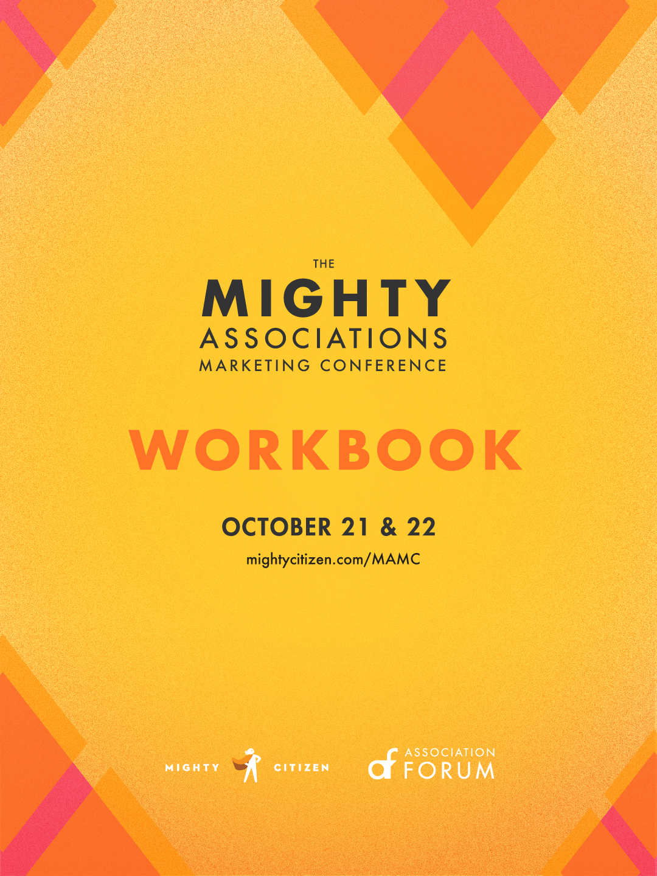

This Conference is for You.
The Mighty Associations Marketing Conference is focused solely on marketing and communications for associations.
We’ve seen a lot of change in 2020 and through it all, associations have continued their work to better the world every day. And as we look to 2021, there’s still much to be done. The next two days are all about how you can make your marketing mightier over the next year. You’ll leave the conference with fresh ideas for your 2021 communications strategy, a grab bag of cutting-edge tactics, and new connections with your peers.

Follow Along
We’ll be posting our favorite Mighty Associations Marketing Conference moments on social media throughout the day. Use this hashtag to join in:

#MAMC20

Schedule
9:00 a.m. | Opening Remarks, Welcome and Ice Breaker Activity
9:20 | Building Your 2021 Communications Plan
10:15 | Workbook Time and Break
10:30 | You’re a Publisher Now: How to Make Your Content Go Further
11:30 | Workbook Time
11:45 | Final Activity for Day One
12:00 p.m. | End of Day One

Wednesday, October 21

Thursday, October 22
9:00 a.m. | Day Two Welcome and Activity
9:20 | Anatomy of an Association Website
10:20 | Workbook Time and Break
10:35 | Hack the Mind: Using Psychology to Engage Your Users
11:30 | Closing Remarks and Takeaways
12:00 p.m. | End of Day Two

Your 2021 Communications Goals

List high priority goals for your communications in 2021.

Goal # 1
Goal # 1 goes here

Activities needed to reach Goal # 1
- Activity # 1 goes here
- Activity # 2 goes here

Your Goals, Continued

Goal # 2

Activities needed to reach Goal # 2

Your Goals, Continued

Goal # 3

Activities needed to reach Goal # 3

Your Content

What’s your best performing content?
How do you know? If you don’t know, how will you get the information?

How can you extend or repackage your best performing content to help you reach your 2021 goals?

Your Website

If you could improve one thing about your website to help you reach your 2021 goals, what would it be?
Look back at your goals. What changes need to be made to your website to help reach them?

Does your website pass the 5-second test?
If so, congrats! If not, what needs to change?

What updates can you make to your website forms to increase conversions?
Ex. Try an anchoring method, simplify my form questions, ask segmentation questions on my confirmation page, etc.

